A Practical WorKbook to assist you building your Healthy food & drink product strategy

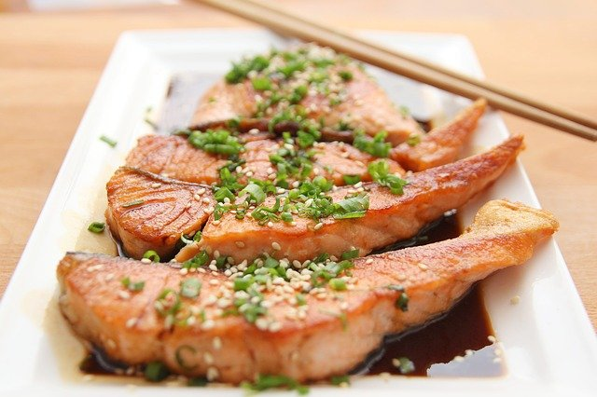

Healthy Food & Drink Product Strategy Workbook

AHFES | P2 -M3 Product Strategy Workbook



**Using the**

**Product Strategy**

**Workbook**

This workbook is designed to be used in conjunction with the AHFES (Atlantic Area Healthy Food Eco-System Project) training module [P2-M3 Product Strategy](https://www.ahfesproject.com/training/p2-m3-creating-a-product-strategy/).

The workbook aims to offer a number of practical approaches that you could undertake to help you define a successful Product Strategy for your healthy food and drink business.

You are most likely passionate about growing your business and brimming with ideas !

But whilst there is often a huge range of new product options that you could pursue, inevitably your time, finances and resources will be limited.

So, you need to sort out what you COULD do, from what you SHOULD do !

Defining a Product Strategy is one very helpful step towards reaching this level of clarity when it comes to managing the portfolio of products that your business will offer.

The aim of a Product Strategy is to ensure that each and every product you bring to market contributes in a positive way to achieving the overall goals that you have identified for your business.

As you use the templates suggested in this workbook, you can apply the concepts explored in the accompanying training module in a practical and helpful way that is focussed on your own unique business circumstances.

It will help you draw together information and insight in a structured way, so that you can focus on the key, important evidence you are gathering and use it to make informed decisions on what products will best achieve your objectives.

By identifying and investigating not only opportunities but also potential hurdles or obstacles to success in your chosen marketplace, your Product Strategy will be robust enough to survive in a competitive market.

Every business is different, so feel free to adapt the templates to suit your own needs.

**Competitor Analysis**

Analysing your competitors’ products and activities in an objective way, can reveal which companies are offering customers viable alternatives to your own products. Also, where you have an opportunity to present a unique and appealing offer.

You can use the techniques we explored in training module P1-M3 Benchmarking to investigate what is happening in the market areas that are of interest to you – or to explore new market sectors that might offer new sales opportunities.

You can reveal valuable insight by critiquing competing products that your current and potential customers could choose to buy – and these might be direct competitors or products that would fulfil a similar role in consumer’s diets and lifestyles.

Think about all aspects of the product and branding, not only the product composition, features or recipes, but their packaging formats, ease of use, product and brand marketing messages, market tier positioning, pricing and promotional techniques.

Think about what you know about customers’ needs and desires, and ask yourself whether all of the features of competitor products really meet these needs ?

Or are they not actually adding any benefits that consumers would value?

Consider the successes or failures of your competitors – what can you learn from their experiences ?

You can gather the information that you uncover into the Benchmarking Template provided with the P1-M3 training module and build up a detailed picture of products already on the market.

By using the Competitor Analysis page in the workbook, you can explore and highlight the most important findings from your competitor review.

You can also add photos of the trends and products you found into the Competitor Analysis Gallery so that you can refer back to them easily.



**Market Insight**

In training module P1-M2 Market Understanding, we explored some of the information that it is helpful for you to know about your current market or a new sector that you are interested to enter.

The Market Information and Analysis page in the workbook allows you to summarise some of your key findings. Despite the many demands on your time, this is a very worthwhile investment to grow and protect your sales.

Building this in depth knowledge about your market, and the dynamics at play within it, allows you to make educated predictions about how your market is evolving. By anticipating changing customer expectations, you can better plan how to stay meaningful and relevant to consumers as they move through different life-stages and experiences.

|  |  |
| --- | --- |
| **COMPETITOR ANALYSIS** | |
| 3 major trends we saw in the market were .. |  |
| 3 key learnings we need to consider are … |  |
| The 3 Competitor Products we found most impressive were .. |  |
| We were impressed with them because … |  |
| We felt they met the needs of their target customers by … |  |
| The 3 Products we felt were poor were … |  |
| They showed us we need to avoid …. |  |
| Opportunities for our business could be … |  |
| Our main challenges will be … |  |
| We could overcome the challenges by … |  |
| Our next steps should be … |  |

|  |  |  |
| --- | --- | --- |
| **COMPETITOR ANALYSIS GALLERY** | | |
| **Market Trend Photo 1** | **Market Trend Photo 2** | **Market Trend Photo 3** |
|  |  |  |
| **Comments :** | **Comments :** | **Comments :** |
| **Best Competitor Product Photo 1** | **Best Competitor Product Photo 2** | **Best Competitor Product Photo 3** |
|  |  |  |
| **Comments :** | **Comments :** | **Comments :** |
| **Poor Competitor Product Photo 1** | **Poor Competitor Product Photo 2** | **Poor Competitor Product Photo 3** |
|  |  |  |
| **Comments :** | **Comments :** | **Comments :** |
| **Other Competitor Analysis Highlights** | | |
|  |  |  |
| **Comments :** | **Comments :** | **Comments :** |

In module P1-M6, which looked at [**Defining your Brand Values**](https://www.ahfesproject.com/training/m6-defining-your-brand-values/), we suggested that you might create a mind map which highlights the unique appeal of your product or brand vs. your key competitors.

Selecting up to 3 competitors, why not capture their positioning and your own unique attributes below ?

You will create a reference to ensure all these important aspects form part of your ultimate product offering.

|  |  |  |  |
| --- | --- | --- | --- |
| **CAPTURING OUR UNIQUE OFFER** | | | |
| **Attributes & Claims**  **Competitor 1**  **Name :** | | **Attributes & Claims**  **Competitor 2**  **Name :** | **Attributes & Claims**  **Competitor 3**  **Name :** |
|  | |  |  |
| **Our Attributes & Claims**  **What is unique & appealing about our offer ?** | | | |
|  | | | |
| **MARKET INFORMATION & ANALYSIS** | | | |
| The market sector we are looking at is … |  | | |
| The products which come within this market are … |  | | |
| We have gathered our information from … |  | | |
| The market is worth … |  | | |
| The areas of the market growing are …  The growth rates are … |  | | |
| The areas of the market declining are …  Decline rates are … |  | | |
| The main sales channels are … |  | | |
| Change in the market is happening because … |  | | |
| The major brands in the market are … |  | | |
| The challenger brands in the market are …. |  | | |
| Tiering in the market is triggered by .. |  | | |
| Our main opportunities would be … |  | | |
| Our main challenges would be … |  | | |
| Our next steps should be … |  | | |

Don’t forget to use the Customer Persona template we offered in training module [P1-M1 Gathering Consumer Insight](https://www.ahfesproject.com/training/m1-gathering-consumer-insight/) to create a one page summary of what you have found out about any specific target customer groups.

**CUSTOMER PERSONAS**

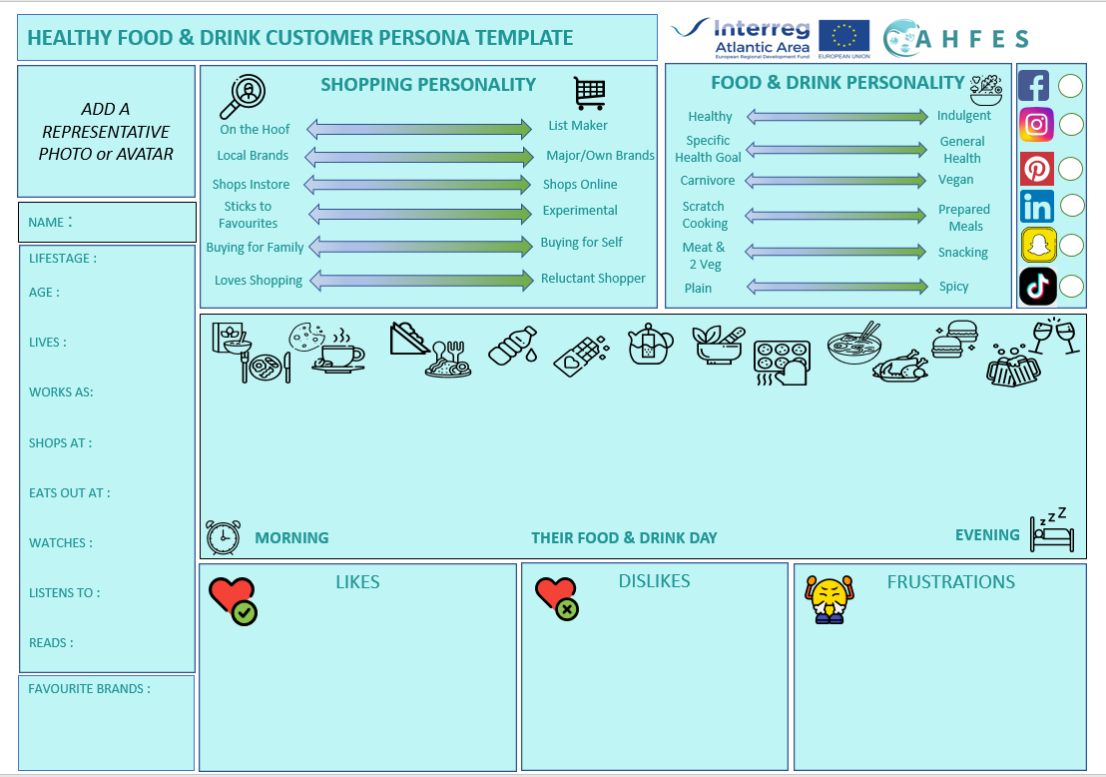Create a separate persona for each target group so that you can easily keep track of what is important to the different target customers you are marketing towards.

Another excellent way you might use a customer persona is to create them for your most loyal, frequent or high spending customers.

Really understanding the motivations and behaviours of your most valuable customers, means that you can take proactive steps to protect this business, by keeping them interested and engaged with your brand. They may even become advocates for your brand and spread the good word about your products !

An additional benefit of this deep understanding of your committed customers, is that it might reveal ways in which you could boost sales by converting people who only purchase sporadically into regular customers.

By using this classic SWOT template, you can create an honest and revealing snapshot ofyour business.

It can help you to build on what you do well, address what you're lacking, anticipate and minimise risks, and creates a focus on where you have the best chances for success.

|  |  |
| --- | --- |
| **BUSINESS SWOT ANALYSIS** | |
| STRENGTHS  **What assets do we have ?**  **What resources can we draw upon ?**  **Where do we excel vs our competitors ?**  **What do we offer that is unique and valued by customers?**  **What connections can we leverage ?** | WEAKNESSES  **Are our goals relevant ?**  **Are they achievable in a realistic timeframe ?**  **Do we have the right staff in the right place ?**  **What knowledge and skills, resources, equipment, raw materials or infrastructure are we lacking ?**  **How are our competitors stronger than us ?** |
| OPPORTUNITIES  **Could there be new markets for our current products?**  **Could we reformulate/ innovate to fill gaps in the market ?**  **Are new sales opportunities arising because consumer behaviour is changing ?**  **How could we reach new customers ?**  **Should we update our marketing strategy ?** | THREATS  **Where are we vulnerable ?**  **How robust is our financial performance ?**  **Are we hitting our performance targets ?**  **What changes could undermine our business ?**  **How would we adapt to new circumstances ?** |



**PRODUCT LIFECYCLE POSITIONING**

Use this chart to indicate where on their product lifecycle your individual products are situated. You can also map your competitors’ products, in the same way, to reveal extra insight into possible opportunities and threats to your own ranges.

**IN STRONG**

**GROWTH**

**Competitor Products**

**Competitor Products**

**Competitor Products**

**Competitor Products**

**DECLINE**

**& EXIT**

Now think about each of your products in detail and plot them on this matrix to determine your strategy for their future. The wider your range, and the longer you have had products in the marketplace, the more likely you are to have products performing in different sectors.

**PRODUCT PERFORMANCE MATRIX**

Is the market that this product is part of in high growth and do you have a high market share? It’s a **STAR**

Is this product’s market stagnant or in decline – but you have a big share of that market? It’s a **CASH COW**

Is this product’s market growing rapidly – but you only have a small market share? It’s a **QUESTION MARK**

Is this product’s market stagnant or in decline – and you only have a small share of that market? It’s a **DOG**

|  |  |  |  |
| --- | --- | --- | --- |
| **HIGH** | **Your Products Relative Market Share** | | **LOW** |
| **Stars**  **Market Growth Rate** | **Make sure you are nurturing these products because they have the highest potential for growing successful sales.** | **These products should be selling well but are not strong in the market. What steps can you take to improve their sales ?** | **Question Marks** |
| **These are your core lines. They sell steadily, have a high market share & can be relied upon to deliver revenue & profit – but don’t take them for granted & lose their benefits.** | **Have these products had their day? With sluggish sales and low market share they may a poor use of resources & need delisting.**  **Unless you can rejuvenate them?** |
| **LOW** |  |  |  |

As you decide what products should form part of your product portfolio, you will want to set targets for their performance so that you will be able to judge their success, both as individual products and in comparison to other lines.

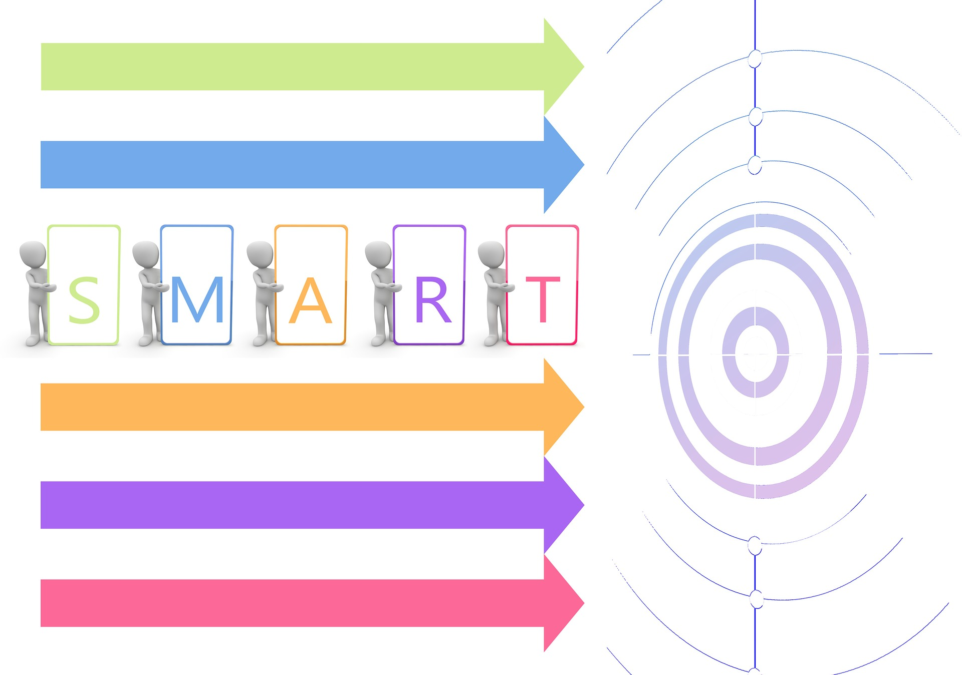

**SPECIFIC**

**TIME-FRAMED**

**RELEVANT**

**MEASURABLE**

**ACHIEVABLE**

**SETTING PRODUCT PERFORMANCE S.M.A.R.T. TARGETS**

To be meaningful and objective, these targets should be **S.M.A.R.T.** – that is they should be Specific, Measurable, Achievable, Relevant and Time Framed.

|  |  |
| --- | --- |
| **POSSIBLE OBJECTIVES FOR YOUR PRODUCT** | |
|  | **What is the Target ? When by ? Who is responsible for achieving this ?** |
| **Sales Value per month** |  |
| **Sales Volume per month** |  |
| **Product Net Profit Margin** |  |
| **Improved Productivity** |  |
| **Cost Savings** |  |
| **Market Share %** |  |
| **Gaining Listings** |  |
| **Gaining Customers** |  |
| **Winning Awards** |  |
| **Generating Valuable Good Publicity & PR** |  |
| **Other** |  |

So, you need to think about target “metrics” – actual figures - and define dates by which these should be achieved. It is helpful to identify who is the leading person responsible for tasks needed to hit these targets as well.

Now you have examined the market in more depth, you can plot the different market positions of products and brands and then decide what would be the best approach for your products and business.

**MARKET APPROACH**

|  |  |  |  |  |
| --- | --- | --- | --- | --- |
| **MARKET LEADERS** | **MARKET CHALLENGERS** | | **MARKET FOLLOWERS** | **MARKET NICHERS** |
| Which brand or brands have the biggest market share ? What is that share?  Is it growing or declining ?  What do you observe makes them market leaders ? | Which brands are challenging the leaders ?  Are they aggressively growing their market share ?  What is driving their success ? | | Which businesses are taking a slice of the market but not innovating themselves ?  What is their approach ?  Are they driving prices downwards ? | Which businesses / brands have successfully targeted a specific market segment ?  Which customers are they targeting ?  Why are they successful ? |
| 1. | 1. | | 1. | 1. |
| % Share =  Share growth or decline =  Key Observations : | % Growth =  Success being driven by .. | | % Share / Growth =  They are affecting the market by …. | Their niche is …  Their target customers are … |
| 2. | 2. | | 2. | 2. |
| % Share =  Share growth or decline =  Key Observations : | % Growth =  Success being driven by .. | | % Share / Growth =  They are affecting the market by …. | Their niche is …  Their target customers are … |
| 3. | 3. | | 3. | 3. |
| % Share =  Share growth or decline =  Key Observations : | % Growth =  Success being driven by .. | | % Share / Growth =  They are affecting the market by …. | Their niche is …  Their target customers are … |
| **OUR MARKET POSITIONING SHOULD BE …** | | | | |
| Select a Position : | | | | |
| The reason for our positioning is … | | | | |
| Creating a Product Vision Statement for the products that you plan to bring to market is a good discipline. It acts as a checklist for considering all the various aspects of the product so you can ensure that it will fit into your product strategy and deliver strong value for your business. | | | | |
| **PRODUCT VISION STATEMENT** | | | | |
| Our new product is called … | |  | | |
| A brief description of it is … | |  | | |
| Our target customers are … | |  | | |
| Our customers told us they were looking for a product which … | |  | | |
| It fulfils the needs of our target customers by …. | |  | | |
| It is uniquely appealing because... | |  | | |
| It is responding to market trends by … | |  | | |
| With the product we aim to … | |  | | |
| This product will contribute to our business goals by … | |  | | |
| We will know we have been successful when we achieve … | |  | | |
| Our analysis of our competitors revealed … | |  | | |
| Our obstacles in bringing this product to market successfully might be … | |  | | |
| We could overcome these by … | |  | | |
| We will review this product in the context of our product strategy on … | |  | | |

We hope that this workbook has helped you to draw togther good quality information which in turn has generated useful insights for your business, and helped you decide your product strategy for healthy food or drink products.

**SUMMARISING AND COMMUNICATING YOUR STRATEGY**

Remember, the best Product Strategies are



Summarising your product strategy allows you to communicate it effectively to your customers, staff and investors. For example you could adapt an overview similar to this below to explain what your strategy is and how you arrived at it :-

**Product Strategy for** (*enter your business or brand name here*)

**Our** (*enter name of product, brand or range*) **product(s) are targeted at customers who are looking for** (*explain the needs and desires of your various target customer groups).*

**Our product(s) deliver(s) this because it/they** (*explain how your products achieve the needs or solve problems for the customers*) **by offering these uniquely appealing attributes** (*outline how your products will stand out from the competition*).

**Our target sales channels are** (*state where and through which outlets you plan to sell*) **and we are confident that there is a strong customer demand because** (*highlight some of your key market intellegence and consumer research facts*).

**Our business is well positioned to bring these products to market because** (*outline some of your key business strengths, knowledge and skills including human and other resources*).

**We are aware of challenges such as** (*define some of the hurdles or risks you have identified*) **but we are confident that by** (*list the steps you plan to take to overcome the challenges*) **we will bring the product(s) to market successfully by** (*add the target launch date*).

**This product/ range will contribute positively to our overall business goals because** (*explain how it/they fit your overall business strategy and aims*).

**We will measure our success against the following targets** (*state your main S.M.A.R.T. targets*).

**We will review our performance on a** (*add the frequency e.g. monthly, quarterly, annually*) **basis so that we can monitor our progress, maximise opportunities and make any adjustments or improvements that may be needed to ensure the product(s) deliver the best possible benefits to our overall business.**

Don’t forget we have a range of other training modules for healthy food and drink producers, which you may also find informative and helpful. So do refer to the [AHFES Project website](https://www.ahfesproject.com/training/) for regular updates or contact the AHFES Partner in your region for more information.